Project Scope statement!

## Project Objectives

To have a working language translation system for use in airport restaurants before August 6th 2021

## Deliverables

Development

1. Java Code for an Android App
2. Code for an iPhone App
3. HTML, CSS and Javascript code for a Web Site
4. C or Python for a web server
5. SQL code for a user database
6. JSON programming for the API

Testing

1. Beta bound
2. PreApps
3. Killer Apps

Financial

1. Find investment
   1. Seed financing
   2. Venture Capitalists (after prototype)
   3. Bank loan
2. Produce a budget

Marketing

1. Advertise
2. Find free trial customers
3. Cold Call

## Milestones

1. Business plan complete
2. Prototype complete
3. Testing complete
4. First customers

## Requirements

Cloud Based Infrastructure

1. Web server
2. Application Server
3. NMT Server
4. SQL Database

Personnel

1. Front End developer
2. Back end developer
3. Business manager
4. Marketing guru

Money

1. Seed money for prototyping
2. Investors for further development

## Context Diagram

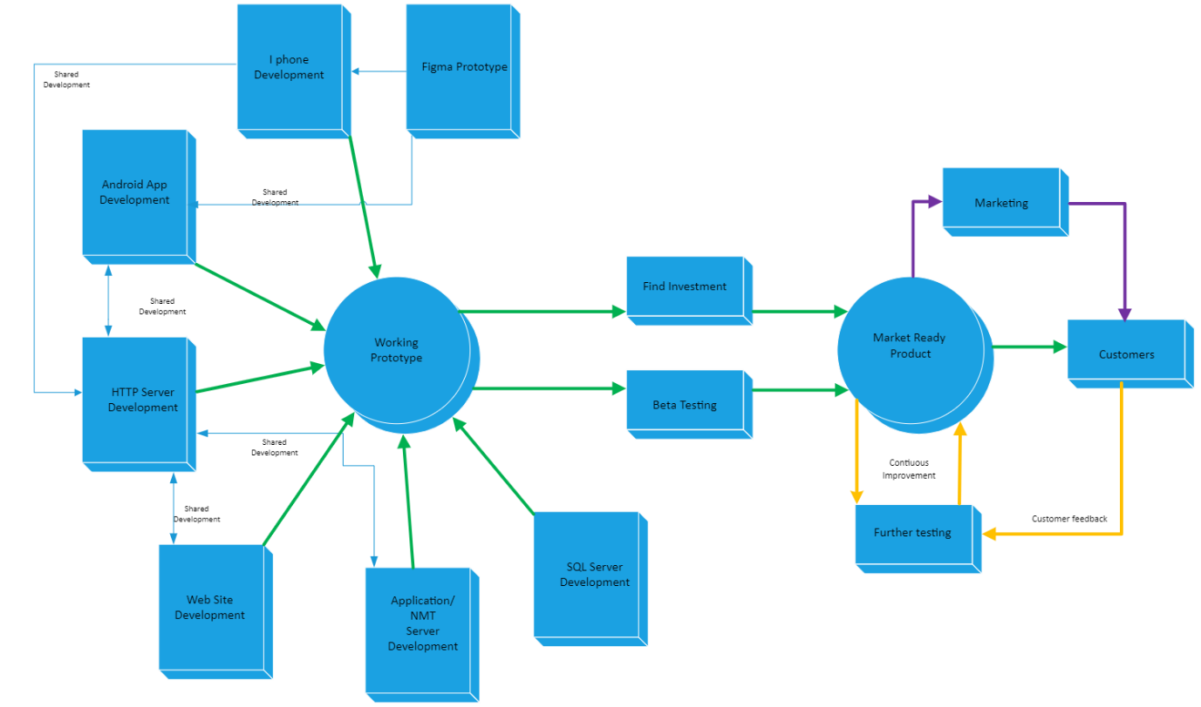

## Constraints

Our largest constraint is going to be time. With only 15 weeks until the deadline, there will be a lot. The team will need to be focused, motivated and well organised. Our second largest constraint will be manpower. Unfortunately we have no ability to onboard more team members, so again the team will need to remain focused.

## Critical Success factors

To be a success, the Project must achieve these goals

1. A working prototype
2. Enough capital to be raised to ensure a market ready product
3. A well tested, market ready product to be produced and released
4. Revenue to start paying dividends to our investors

## Assumptions

Assumptions that we can make at the beginning of this project

1. We have a dedicated team
2. We all have 36 hours per person for project work before May 28th
3. We have 10 hours per person, per week from May 28th to August 6th
4. That airports will be running by August 6th
5. That our App has a market
6. Our App is unique
7. We can raise seed money between the group